Exercise A: Insert new rows into the table EMPLNEW1 you already created:
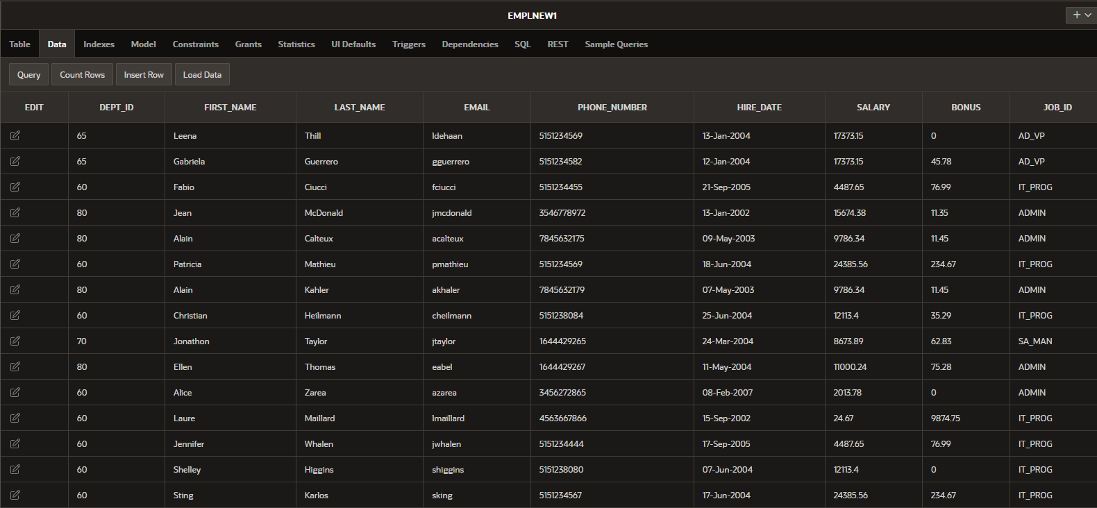
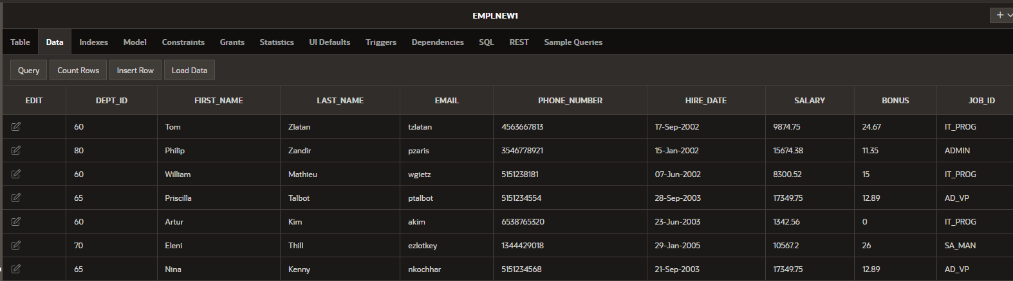
Use EMPLNEW1 table for the following:
Exercise B: Check if the following commands have errors or not. Justify the answer:
1.select * for EMPLNEW1
select *
From EMPLNEW1
2.select sum(salary), max(salary) from EMPLNEW1

3.select * EMPLNEW1 where job_id=st_clerk
select * from EMPLNEW1 where job_id='st_clerk'

4.select first name, last name, salary from EMPLNEW1
select first_name, last_name, salary from EMPLNEW1

5.select first_name, last_name from EMPLNEW1 where salary<7500

6.select salary where department_id=80 from EMPLNEW1
SELECT salary
FROM EMPLNEW1
WHERE dept_id = 80;

7.select first_name, last_name, salary order by salary from EMPLNEW1
select first_name, last_name, salary from EMPLNEW1 order by salary

8.select first_name, last_name from EMPLNEW1 where salary>7000

9.select *, first_name, last_name from EMPLNEW1
Eiter * or first_name, last_name

10.select first_name, last_name, salary order by salary from EMPLNEW1
select first_name, last_name, salary from EMPLNEW1 order by salary

11.select first_name, last_name where salary>7000 from EMPLNEW1
select first_name, last_name from EMPLNEW1 where salary>7000

12.select avg(salary) from EMPLNEW1

13.select last_name, avg(salary) from EMPLNEW1
You can’t display anyting else when you put something like this: avg(salary)

14.select first_name, last_name from EMPLNEW1 where hire_date>(select hire_date from EMPLNEW1 where last_name='Kim')

15.select first_name, last_name from EMPLNEW1 where hire_date>(select hire_date from EMPLNEW1 where last_name='Thill')
There is no 'Thill'

16.select first_name, last_name from EMPLNEW1 where salary>(select salary from EMPLNEW1 where last_name=' Mathieu ')
In this case 'Mathieu' can’t have space in the from and behind and ' Mathieu ' is there twice.

17.select first_name, last_name from EMPLNEW1 where hire_date>(select salary from EMPLNEW1 where last_name='Thill')
'Thill' is there twice.

18.select first_name, last_name from EMPLNEW1 where salary>(select avg(salary) from EMPLNEW1 where last_name='Thill')
It’s for an avrave of both Thill

19.select first_name, last_name from EMPLNEW1 where hire_date>(select hire_date from EMPLNEW1 where last_name='Thill')
'Thill' is there twice.

20.select first_name, last_name from EMPLNEW1 where dept_id>(select dept_id from EMPLNEW1 where last_name=' Taylor')
select first_name, last_name from EMPLNEW1 where dept_id>(select dept_id from EMPLNEW1 where last_name='Taylor')
There shouln’t be a space infront of Taylor

Exercise C:
21.Display all the information about the employees.
SELECT *
FROM employees

22.Display the last_name and the first_name with uppercase letters in one column.
SELECT upper(last_name)|| ' '||upper(first_name)
FROM employees

23.Display the sum of the salary for employees having job_id= IT_PROG or ADMIN.
SELECT sum(salary)
FROM employees
WHERE job_id in ('IT_PROG','ADMIN' )

24.Increase the salary of employees by 5% and display the last_name, the first_name the old salary, and the new salary.
SELECT last_name, first_name, salary, salary*salary+0,05
FROM employees

25.Increase the salary of employees by bonus and display all the information.
SELECT EMPLOYEE_ID, FIRST_NAME, LAST_NAME, EMAIL, PHONE_NUMBER, HIRE_DATE, JOB_ID, SALARY, COMMISSION_PCT, MANAGER_ID, DEPARTMENT_ID, BONUS, salary+bonus
FROM employees

26.Decrease the salary of employees by 7% and display the last_name, the first_name, the old salary, and the new salary. Use an alias(NEW_SALARY) to display the new salary.
SELECT last_name, first_name, salary, salary-salary*0.07 AS "NEW_SALARY"
FROM employees;

27.Display all the information about the employees having job_id “IT_PROG” and the salary<15000.
SELECT *
FROM employees
WHERE job_id='IT_PROG' and salary<15000

28.Display the average of the salary for employees having dept_id= 60 and round the result to 3 decimal places.
SELECT round(avg(salary),3)
FROM employees
WHERE department_id=60
29.Display all the information for employees having job_id=IT_PROG and arrange in descending order according to salary.
SELECT *
FROM employees
WHERE job_id='IT_PROG'
order by salary DESC

30.Display the first_name and the last_name in uppercase in a new column „New”, and the dept_id for employees having dept_id=60 or 80(two methods).
SELECT UPPER(first_name) || ' ' || UPPER(last_name) AS "New", department_id
FROM employees
WHERE department_id in (60, 80);

SELECT UPPER(first_name) || ' ' || UPPER(last_name) AS "New", department_id
FROM employees
WHERE department_id = 60 OR department_id = 80;

31.Display the first_name, the last_name the salary and the dept_id for employees having dept_id ≠ 65.
SELECT first_name, last_name, salary, department_id
FROM employees
WHERE department_id != 65

32.Display all the information for employees having “o” or “a” in their last names.
SELECT *
FROM employees
WHERE last_name like '%o%' or last_name like '%a%';

33.Display all the information for employees whose last names start with “K” or „Z”. Arrange in order according to salary.
SELECT *
FROM employees
WHERE last_name like 'K%' or last_name like 'Z%'
order by salary

34.Display all the information about the employees hired after 1st January 2004.
SELECT *
FROM employees
WHERE hire_date>'01-Jan-2004'

35.Display the maximum of the salary for employees having job_id=AD_VP or IT_PROG.
SELECT max(salary)
FROM employees
WHERE job_id in ('AD_VP', 'IT_PROG')

36.Display the average of the salary and round the result to 2 decimal places for employees having job_id=AD_VP or IT_PROG.
SELECT round(avg(salary), 2)
FROM employees
WHERE job_id in ('AD_VP', 'IT_PROG')

37.Display the first_name, the last_name, the dept_id and the salary for employees having bonus. Arrange in order according using last_name.
SELECT first_name, last_name, department_id, salary
FROM employees
WHERE bonus is not NULL
ORDER BY last_name

38.Increase the salary of employees having job_id IT_PROG or AD_VP by 5% and display first_name, last_name, salary and the new salary using an alias.
SELECT first_name, last_name, salary, (salary+salary* 0.05) as "new_salary"
FROM employees
WHERE job_id in ('IT_PROG', 'AD_VP');

39.Decrease the salary of employees by 5% and display first_name, last_name, salary and the new salary for employees having dept_id=60 or 80.
SELECT first_name, last_name, salary, (salary-salary* 0.05)
FROM employees
WHERE department_id in ('60', '80');

40.Display all the information about the employees having salary between 10000 and 15000.
SELECT *
FROM employees
WHERE salary between 10000 and 15000

41.Arrange in order according to salary and display first_name, last_name, salary for all employees.
SELECT first_name, last_name, salary
FROM employees
ORDER BY salary

42.Display all the information about the employees having job_id=IT_PROG.
SELECT *
FROM employees
WHERE job_id='IT_PROG'

43.Display the last_name and the first_name in capital letters in a new column “Name” for employees having dept_id=80.
SELECT UPPER(CONCAT(last_name, first_name)) as "Name"
FROM employees
WHERE department_id = 80

44.Display in one column the first character of the first name concatenated to the last_name, and the email for all employees.
SELECT concat(concat(substr(first_name, 1, 1), last_name), email)
FROM EMPLNEW1;

45.Display in one column the last_name concatenated to the first character of the first_name, the salary, and the dept_id for employees having dept_id=60, 65 or 70 (two methods).
select concat(concat(concat(last_name,substr(first_name, 1, 1)), salary), dept_id)
from EMPLNEW1
where dept_id in (60,65,70)

46.Increase the bonus for employees hired after 01.01.2005 by 10%, and display all the information.
SELECT DEPT_ID, FIRST_NAME, LAST_NAME, EMAIL, PHONE_NUMBER, HIRE_DATE, SALARY, BONUS, JOB_ID, bonus+bonus*0.10
FROM EMPLNEW1
WHERE hire_date > '01-Jan-2005'

47.Arranging in descending order according to hire_date and display first_name, last_name, salary.
SELECT first_name, last_name, salary
FROM employees
ORDER BY hire_date DESC

48.Decrease the bonus of employees having job_id= IT_PROG, by 3%. Display the first_name, the last_name, the old salary, and the new one.
select first_name, last_name, salary, bonus-bonus*0.03
from EMPLNEW1
where job_id= 'IT_PROG'

49.Display all the information about the employees hired between January 1, 2004 and December 31, 2005.
select *
from EMPLNEW1
where hire_date between '01-Jan-2004' and '31-Dec-2005'

50.Display the maximum of bonus for all the employees.
select max(bonus)
from EMPLNEW1

51.Display the minimum of bonus for employees having dept_id=80.
select min(bonus)
from EMPLNEW1
where dept_id=80

52.Using a substitution variable, display the first_name, the last_name, and the dept_id for employees having dept_id=70 or 60.
select first_name, last_name, dept_id
from EMPLNEW1
WHERE dept_id=:enter_dept_id

53.Using a substitution variable for job_id, display the first_name, the last_name, the dept_id, and the job_id for employees having job_id=IT_PROG or ADMIN.
select first_name, last_name, dept_id, job_id
from EMPLNEW1
WHERE job_id=:enter_job_id

54.Using a substitution variable for dept_id, display the first_name, the last_name, the dept_id, the hire_date and the salary for employees having department_id=80 or 50 and hired after 01.05.1998.
select first_name, last_name, dept_id, hire_date, salary
from EMPLNEW1
WHERE dept_id=:enter_dept_id and hire_date>'01-May-1998'

55.Using a group function, display the last name in alphabetical order.
SELECT last_name
FROM EMPLNEW1
ORDER BY last_name ASC;
Exercise D:
1.Write a select to return the first_name, the last_name, the salary from employees who earn more than Zarea(last_name).
SELECT first_name, last_name, salary
FROM EMPLNEW1
WHERE salary>(SELECT salary FROM EMPLNEW1 WHERE last_name = 'Zarea')

2.Write a select to return all the information about employees having the same department as Thill.
SELECT *
FROM EMPLNEW1
WHERE dept_id =(SELECT dept_id FROM EMPLNEW1 WHERE last_name = 'Thill')
It won’t work with Thill

3.Display the first_name, the last_name, and the salary from employees who earn less than the average of salaries from employees having job_id=IT_PROG.
SELECT first_name, last_name, salary
FROM EMPLNEW1
WHERE salary <(SELECT avg(salary) FROM EMPLNEW1 WHERE job_id='IT_PROG')

4.Display the first_name, the last_name, and the salary from employees hired after Zlatan.
SELECT first_name, last_name, salary
FROM EMPLNEW1
WHERE hire_date>(SELECT hire_date FROM EMPLNEW1 WHERE last_name = 'Zlatan')

5.Display the first_name, the last_name, and the salary from employees having the same job_id like Zlatan .
SELECT first_name, last_name, salary
FROM EMPLNEW1
WHERE job_id =(SELECT job_id FROM EMPLNEW1 WHERE last_name = 'Zlatan')

6.Display first_name, last_name, and the salary from employees who earn less than the average of the salaries for employees hired after Zlatan.
SELECT first_name, last_name, salary
FROM EMPLNEW1
WHERE salary < (SELECT avg(salary) FROM EMPLNEW1 WHERE hire_date > (SELECT hire_date FROM EMPLNEW1 WHERE last_name = 'Zlatan'));

7.Display the first_name, the last_name, and the salary for employees who earns more than the average of the salaries for all the employees having dept_id=60.
SELECT first_name, last_name, salary
FROM EMPLNEW1
WHERE salary > (SELECT avg(salary) FROM EMPLNEW1 WHERE dept_id = 60)

8.Display first_name, last_name, and the salary from employees who earn more than the minimum salaries for employees hired after Taylor.
SELECT first_name, last_name, salary
FROM EMPLNEW1
WHERE salary > (SELECT min(salary) FROM EMPLNEW1 WHERE hire_date > (SELECT hire_date FROM EMPLNEW1 WHERE last_name = 'Taylor'))

9.Display the first_name, the last_name, the salary, the job_id and the dept_id for employees having the same job_id like Taylor.
SELECT first_name, last_name, salary, job_id, dept_id
FROM EMPLNEW1
WHERE job_id = (SELECT job_id FROM EMPLNEW1 WHERE last_name = 'Taylor')

10.Display the first_name, the last_name, and the salary for employees having the same dept_id like Taylor.
SELECT first_name, last_name, salary
FROM EMPLNEW1
WHERE dept_id = (SELECT dept_id FROM EMPLNEW1 WHERE last_name = 'Taylor')

11.Increase the salary for employees hired after Kim by 500 euros and display first_name, last_name, the old salary and the new one.
SELECT first_name, last_name, salary, salary+500
FROM EMPLNEW1
WHERE hire_date > (SELECT hire_date FROM EMPLNEW1 WHERE last_name = 'Kim')

12.Display the first_name, the last_name, and the salary for employees who earn more than the average salaries for all the employees having dept_id=60 or 65.
SELECT first_name, last_name, salary
FROM EMPLNEW1
WHERE salary > (SELECT avg(salary) FROM EMPLNEW1 WHERE dept_id in (60, 65))

13.Display the first_name, the last_name, and the salary for employees who earn more than the average salaries for all the employees having job_id= AD_VP or IT_PROG.
SELECT first_name, last_name, salary
FROM EMPLNEW1
WHERE salary > (SELECT avg(salary) FROM EMPLNEW1 WHERE job_id in ('AD_VP', 'IT_PROG'))

14.Display the first_name, the last_name, and the salary in a new column named “Information” for employees hired before Higgins.
SELECT first_name || '' || last_name || '' || salary as "Information"
FROM EMPLNEW1
WHERE hire_date < (SELECT hire_date FROM EMPLNEW1 WHERE last_name = 'Higgins')

15.Display the last_name and the first_name with uppercase letters in one new column “Name” for employees having the same job_id as Zarea.
SELECT Upper(last_name) ||' '|| upper(first_name) as "Name"
FROM EMPLNEW1
WHERE job_id = (SELECT job_id FROM EMPLNEW1 WHERE last_name = 'Zarea')

16.Arrange all the employees having the same department as Kim using salary, and display first_name, last_name and the salary.
SELECT first_name, last_name, salary
FROM EMPLNEW1
WHERE dept_id = (SELECT dept_id FROM EMPLNEW1 WHERE last_name = 'Kim')
ORDER BY salary;

17.Arrange all the employees hired after Kim using hire_date, and display first_name, last_name, salary and the hire_date.
SELECT first_name, last_name, salary
FROM EMPLNEW1
WHERE hire_date > (SELECT hire_date FROM EMPLNEW1 WHERE last_name = 'Kim')
ORDER BY hire_date

18.Decrease the salary with 200 and display the first_name, the last_name, and the new salary for employees hired after Kim.
SELECT first_name, last_name, salary-200
FROM EMPLNEW1
WHERE hire_date > (SELECT hire_date FROM EMPLNEW1 WHERE last_name = 'Kim')

19.Arrange all the employees using hire_date, and display last_name, the hire_date and the dept_id from employees who earn more than Kim(last_name).
SELECT last_name, hire_date, dept_id
FROM EMPLNEW1
WHERE salary > (SELECT salary FROM EMPLNEW1 WHERE last_name = 'Kim')
ORDER BY hire_date

20.Arrange all the employees having the same department as Ellen(first_name) using salary, and display first_name, last_name and the salary.
SELECT first_name, last_name, salary
FROM EMPLNEW1
WHERE dept_id = (SELECT dept_id FROM EMPLNEW1 WHERE first_name = 'Ellen')
ORDER BY salary

21.Arrange all the employees hired after Ellen(first_name) using salary, and display first_name, last_name, salary and the hire_date.
SELECT first_name, last_name, salary, hire_date
FROM EMPLNEW1
WHERE hire_date > (SELECT hire_date FROM EMPLNEW1 WHERE first_name = 'Ellen')
ORDER BY salary

22.Display all the information about employees who earn more than the average salary for employees where job_id = ADMIN or AD_VP.
SELECT *
FROM EMPLNEW1
WHERE salary > (SELECT avg(salary) FROM EMPLNEW1 WHERE job_id in ('ADMIN', 'AD_VP'))

23.Display the first_name and the last_name in the same column “Name” for employees having the same job_id like Kim.
SELECT first_name || '' || last_name as "Name"
FROM EMPLNEW1
WHERE job_id > (SELECT job_id FROM EMPLNEW1 WHERE last_name = 'Kim')

24.Display the last_name, and the salary for employees who earns more than the minimum salaries for all the employees having dept_id=80.
SELECT last_name, salary
FROM EMPLNEW1
WHERE salary > (SELECT min(salary) FROM EMPLNEW1 WHERE dept_id=80)

25.Display the first_name, last_name and the salary for employees having the same dept_id like Thomas and orders in descending order using salary.
SELECT first_name, last_name, salary
FROM EMPLNEW1
WHERE dept_id = (SELECT dept_id FROM EMPLNEW1 WHERE last_name = 'Thomas ')

26.Increase the salary of employees working in the same department like Thomas by 10 % and display the last_name, the new salary and the dept_id.
SELECT last_name, salary+salary*0.10, dept_id
FROM EMPLNEW1
WHERE dept_id = (SELECT dept_id FROM EMPLNEW1 WHERE last_name = 'Thomas ')

27.Decrease the salary by 3% and display the last_name, the old salary and the new salary for all the employees hired after Whalen.
SELECT last_name, salary-salary*0.03, salary
FROM EMPLNEW1
WHERE hire_date > (SELECT hire_date FROM EMPLNEW1 WHERE last_name = 'Whalen ')

28.Decrease the salary by 300 euros and display the last_name, the old salary and the new salary for employees having the same job_id like Zlatan.
SELECT last_name, salary-300, salary
FROM EMPLNEW1
WHERE job_id = (SELECT job_id FROM EMPLNEW1 WHERE last_name = 'Zlatan')

29.Display the first_name in uppercase for all the employees having the same department like Kim.
SELECT upper(first_name)
FROM EMPLNEW1
WHERE dept_id = (SELECT dept_id FROM EMPLNEW1 WHERE last_name = 'Kim')

30.Display the last_name and the hire_date from the first employee in alphabetical order(use to arrange last_name)
SELECT last_name, hire_date
FROM EMPLNEW1
ORDER BY last_name

Exercise E: Use the DUAL table for the following:
1.Display the next Monday after the current date.
SELECT NEXT_DAY(SYSDATE, 'MONDAY')
FROM DUAL

2.Display the current date and the sysdate.
SELECT current_date, SYSDATE
FROM DUAL

3.Display the last day of this month.
SELECT LAST_DAY(SYSDATE)
FROM DUAL

4.Starting with the string “project”, display projec. (use function SUBSTR)
SELECT SUBSTR('project', 1, 6)
FROM DUAL

5.Starting with the string “aacbbraa”, display cbbraa. (use function TRIM)
SELECT TRIM(LEADING'a' FROM 'aacbbraa')
FROM DUAL;

6.Use a command to display the length of the string “ The first project”?
SELECT Length('The first project')
FROM DUAL;

7.Use a command to display the position of “i” in “ The first project”?
SELECT INSTR('The first project', 'i')
FROM DUAL;

8.Using the three separate words “Oracle,” “Internet,” and “Academy,” use one command to produce the following output: “Oracle Internet Academy”.
SELECT 'Oracle' || ' ' || 'Internet' || ' ' || 'Academy'
FROM DUAL;

CONCAT(CONCAT('Oracle', ' '), CONCAT('Internet', ' Academy'))

9.Use the string “Oracle Internet Academy” to produce the following output: “net”
SELECT SUBSTR('Oracle Internet Academy', 13, 3)
FROM DUAL;

10.Starting with the string “Oracle Internet Academy”, pad the string to create ****Oracle Internet Academy****.
SELECT lpad(rpad('Oracle Internet Academy', 27, '*'),31, '*')
FROM DUAL;

11.Starting with the string “Oracle Internet Academy”, pad the string to create ****Oracle****Internet****Academy****.
SELECT replace(lpad(rpad('Oracle Internet Academy', 27, '*'),31, '*'), ' ', '****')
FROM DUAL;

12.Using the string ‘Oracle Internet Academy’, produce the output shown using the REPLACE function: “Oracle 2022-2023 Academy”.
SELECT REPLACE('Oracle Internet Academy', 'Internet', '2022-2023')
FROM DUAL;

13.Write a statement that will convert 86.678 to 86.68.
SELECT round(86.678, 2)
FROM DUAL;

14.Write a statement that will convert 86.678 to 86.67.
SELECT TRUNC(86.678, 2)
FROM DUAL;

